1. **QUIP**

* 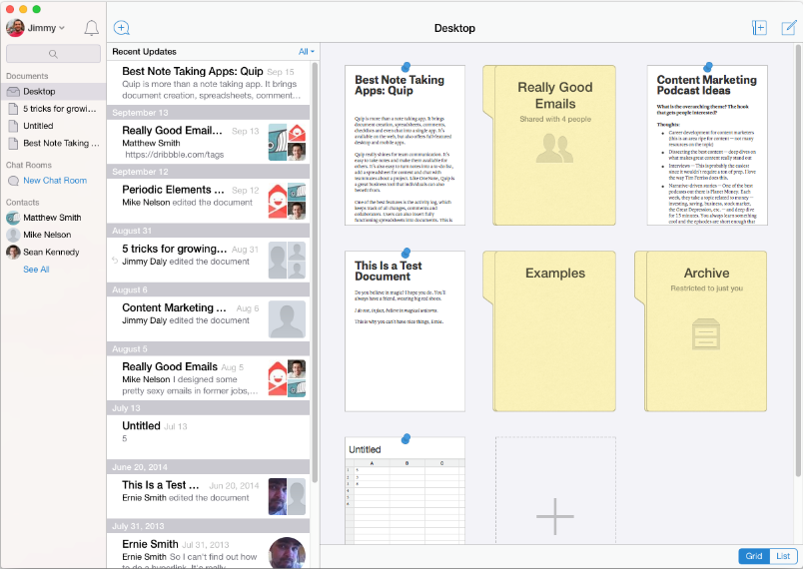<https://zapier.com/blog/best-note-taking-apps/>
* **Quip (iOS, Android, Mac, Windows, Web)**
* Best for combining notes with documents and spreadsheets
* [Quip](http://quip.com/?utm_source=zapier.com&utm_medium=referral&utm_campaign=zapier) isn't your typical notebook app. It starts with notes, then adds in simple document creation, spreadsheets, and even team chat. Each item is saved to its own file, but you can search through everything from Quip's interface and embed documents or spreadsheets into other Quip documents.
* Quip shines with its fast and unique interface. Instead of detailed formatting options, Quip includes document styles that let you reformat your notes in a click. You can then publish your notes to the web, or save them as a PDF to share later. As [one user wrote with Quip](https://quip.com/I8Y5AbQWXmrY?utm_source=zapier.com&utm_medium=referral&utm_campaign=zapier), “The time between a thought and its digital instantiation is the lowest I've seen.”
* Quip really shines for team communication. You can add anyone to a document or note, and work together with every change listed on the left sidebar so it's easy to see what each person added. Or, if you have a question, just type in the sidebar and you'll have a quick team chat. And if you need to crunch numbers in your notes, you'll find Quip's built-in simple spreadsheets are far more useful than the tables in your average notebook app.

1. **SPRINGNOTE**

* 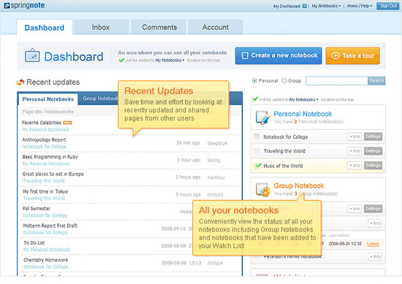<https://www.sitepoint.com/10-notebook-applications-for-managing-ideas/>
* A free online wiki-based notebook that allows you to compile and share ideas, multimedia, projects, and documents. Springnote allows you to create pages, to work on them with others, and to share files. It includes advanced search capability, templates, and 2GB of free file storage.

# **10. Circus Ponies Notebook** **(OS X, iPad)**

* <http://www.lifehack.org/articles/productivity/the-top-12-note-taking-apps-to-get-stuff-done-in-school.html>
* If you like OneNote but want something on the Mac, then [Circus Ponies Notebook](http://www.circusponies.com/notebook/stay-organized) is the app you are looking for. One of the coolest features for students is the ability to create detailed indexes of your notes as well as export your notebooks as full-fledged websites. With some free server space from your school and Circus Ponies Notebook, you are going to be everyone’s friend whe you sharing your notes. Oh, and there is an attractive iPad app that syncs with your Mac.
* <https://en.wikipedia.org/wiki/Circus_Ponies_NoteBook>
* **Circus Ponies NoteBook**, also known as simply **NoteBook**, was a [note-taking](https://en.wikipedia.org/wiki/Note-taking) and organizational application available for [OS X](https://en.wikipedia.org/wiki/OS_X) and [iOS](https://en.wikipedia.org/wiki/IOS). NoteBook supports structured and free-form note taking, information gathering, sketching, diagramming, and PDF mark-up.

# **11. GNOTE**

* <https://en.wikipedia.org/wiki/Gnote>
* **Gnote** is a free and [open-source](https://en.wikipedia.org/wiki/Open-source) desktop [note-taking](https://en.wikipedia.org/wiki/Notetaking) application written for [Linux](https://en.wikipedia.org/wiki/Linux), cloned by Hubert Figuière from [Tomboy](https://en.wikipedia.org/wiki/Tomboy_(software)).[[2]](https://en.wikipedia.org/wiki/Gnote#cite_note-why-2)It uses a [Wiki](https://en.wikipedia.org/wiki/Wiki#Linking_and_creating_pages)-like linking system to connect notes together. Gnote is part of the [GNOME](https://en.wikipedia.org/wiki/GNOME) desktop environment, often filling the need for [personal information management](https://en.wikipedia.org/wiki/Personal_information_management). The main principle is a notepad with a wiki-style interface. Words in the note body that match existing note titles [automatically become hyperlinks](https://en.wikipedia.org/wiki/AutoLink), allowing for the management of large libraries of personal information, such as references to favorite artists that would then automatically be highlighted in notes containing their names. [Plugins](https://en.wikipedia.org/wiki/Plugins) extend the program to include functionality like exporting to [HTML](https://en.wikipedia.org/wiki/HTML) and printing support. As of version 0.8.0, Gnote has been ported to [GTK+3](https://en.wikipedia.org/wiki/GTK%2B).

# **12. ZIM**

* <https://en.wikipedia.org/wiki/Zim_(software)>
* **Zim** is a graphical [text editor](https://en.wikipedia.org/wiki/Text_editor) designed to maintain a collection of locally stored [wiki](https://en.wikipedia.org/wiki/Wiki)-pages, a personal wiki.[[1]](https://en.wikipedia.org/wiki/Zim_(software)#cite_note-1)[[2]](https://en.wikipedia.org/wiki/Zim_(software)#cite_note-2)[[3]](https://en.wikipedia.org/wiki/Zim_(software)#cite_note-3)[[4]](https://en.wikipedia.org/wiki/Zim_(software)#cite_note-4) Each wiki-page can contain things like text with [simple formatting](https://en.wikipedia.org/wiki/Lightweight_markup_language" \o "Lightweight markup language), links to other pages, attachments, and images. Additional [plugins](https://en.wikipedia.org/wiki/Plug-in_(computing)" \o "Plug-in (computing)), such as an equation editor and spell-checker, are also available. The wiki-pages are stored in a folder structure in plain text files with [wiki formatting](https://en.wikipedia.org/wiki/Wiki_markup).
* *Zim* is written in [Python](https://en.wikipedia.org/wiki/Python_(programming_language)" \o "Python (programming language)) using [GTK+](https://en.wikipedia.org/wiki/GTK%2B" \o "GTK+)libraries. It is [free software](https://en.wikipedia.org/wiki/Free_software) licensed under the [GNU General Public License](https://en.wikipedia.org/wiki/GNU_General_Public_License) (GPL).

# **13. MEMONIC**

* <https://en.wikipedia.org/wiki/Memonic>
* **Memonic** is an online notetaking application that allows users to save and organize information while conducting research online and offline. A clip may be a full webpage or webpage excerpt, a document or document excerpt, a text note, or a screenshot. Memonic was launched early 2010.

## Product characteristics

* Memonic offers a full online notetaking application for a number of platforms. Content may be clipped using a range of bookmarklets and extensions for various browsers or by using the desktop application. The online application works on any standard browser.
* Notes can also be added by email, or composed from scratch. Notes can be organized in folders, edited, commented and searched. A user can also create groups to share notes and collaborate with a closed user group.
* Memonic operates on a [freemium](https://en.wikipedia.org/wiki/Freemium" \o "Freemium) model with a free plan limited to 100 notes and a paid plan costing $28 per year for unlimited notes.

# **14. LAVERNA**

* <https://github.com/Laverna/laverna>
* Laverna is a JavaScript note taking application with Markdown editor and encryption support. Consider it like open source alternative to Evernote.
* <https://laverna.cc/>

# **15. TURTL**

* <https://turtlapp.com/>

# **What is Turtl?**

* It's a private place to keep your notes, research, passwords, bookmarks, dream logs, photos, documents and anything else you want kept safe. Turtl's easy tagging and filtering make it ideal for organization and research whether for personal or professional projects.
* Think of Turtl as Evernote with ultimate privacy.