**THE BEST APPS FOR TAKING NOTES**

Notes come in all shapes and sizes—but if you want a notes app to keep track of everything, you'll need a full featured notes app. These apps let you keep your text notes organized, and include extra features to add notes, import images, recognize text from handwriting, and more.

|  |  |  |  |  |
| --- | --- | --- | --- | --- |
| **App** | **Icon:** | **Best for:** | **Price** | **Supports:** |
| [Evernote](https://zapier.com/blog/best-note-taking-apps/#Evernote) | [Evernote](https://zapier.com/blog/best-note-taking-apps/#Evernote) | taking notes, clipping web pages and recording audio | Free; from $25/yr Plus plan | iOS, Android, Mac, Windows, Web |
| [Microsoft OneNote](https://zapier.com/blog/best-note-taking-apps/#OneNote) | [OneNote](https://zapier.com/blog/best-note-taking-apps/#OneNote) | organizing thoughts, to-do lists, and projects | Free; from $69/year for full Office 365 | iOS, Android, Mac, Windows, Web |
| [Google Keep](https://zapier.com/blog/best-note-taking-apps/#Keep) | [Google Keep](https://zapier.com/blog/best-note-taking-apps/#Keep) | collecting images, drafting documents, and creating checklists | Free | iOS, Android, Web |
| [Zoho Notebook](https://zapier.com/blog/best-note-taking-apps/#zoho) | [Zoho Notebook](https://zapier.com/blog/best-note-taking-apps/#zoho) | visually organizing multiple note formats | Free | Mac, iOS, Android |
| [Simplenote](https://zapier.com/blog/best-note-taking-apps/#Simplenote) | [Simplenote](https://zapier.com/blog/best-note-taking-apps/#Simplenote) | taking notes without distraction | Free | iOS, Android, Mac, Web |
| [Apple Notes](https://zapier.com/blog/best-note-taking-apps/#Anotes) | [Anotes](https://zapier.com/blog/best-note-taking-apps/#Anotes) | quickly taking notes on Apple devices | Free; extra iCloud storage from $0.99/month | iOS, Mac, Web |
| [Hackpad](https://zapier.com/blog/best-note-taking-apps/#Hackpad) | [Hackpad](https://zapier.com/blog/best-note-taking-apps/#Hackpad) | collaborative brainstorming | Free; $2/month per user | iOS, Web |
| [Quip](https://zapier.com/blog/best-note-taking-apps/#Quip) | [Quip](https://zapier.com/blog/best-note-taking-apps/#Quip) | combining notes with documents and spreadsheets | Free; from $10/month | iOS, Android, Mac, Windows, Web |
| [Dropbox Paper](https://zapier.com/blog/best-note-taking-apps/#dbpaper) | [Dropbox paper](https://zapier.com/blog/best-note-taking-apps/#dbpaper) | discussing projects inside Dropbox | Free included with Dropbox account | Web |
| [Box Notes](https://zapier.com/blog/best-note-taking-apps/#box) | [Box Notes](https://zapier.com/blog/best-note-taking-apps/#box) | simple notes in Box folders | Free; included with Box account | iOS, Android, Web |
| [Bear](https://zapier.com/blog/best-note-taking-apps/#bear) | [Bear](https://zapier.com/blog/best-note-taking-apps/#bear) | organizing notes, minimalist Markdown editor | Free; $1.49/mo | iOS, Mac |

1. **EVERNOTE**

Evernote-logo.svg

* + <https://www.techlicious.com/tip/best-note-taking-apps-and-devices/>
  + Evernote has been around longer than OneNote, but these days, OneNote matches it nearly feature for feature. Evernote offers more features, with photo scanning software to digitize your receipts ([Scannable](https://help.evernote.com/hc/en-us/articles/208430668-Quick-start)) and digital note-taking app ([Penultimate](https://help.evernote.com/hc/en-us/articles/209122017-Quick-start)), as well as more ways to organize. But the cost is an extra complication. While the basic version of Evernote is free, if you want more storage space, the ability to edit documents offline and access to customer support, it costs $34.99 per year. To add the capability to search for text in PDFs and Word documents, scan business cards and browse note history, you’ll have to upgrade to Evernote Premium for $64.99 per year.
  + Since Evernote and OneNote work on the same platforms, it’s hard to recommend subscription-based Evernote over OneNote unless you really do need all of its premium features.
  + With [Evernote](http://evernote.com/) being avaailable for iOS, Android, Mac, and Windows, it’s no wonder that it is still considered by many to be the world’s best note taking application and utility.
  + <https://www.slant.co/topics/697/viewpoints/2/~best-cross-platform-note-taking-app~evernote>
  + [Evernote](http://evernote.com/) is a cross-platform note taking and idea capture utility that automatically syncs to the company's cloud service. It allows you to easily save websites, photos, and text for later usage or collaboration purposes.
  + **PROS**

### PRO Consolidates all your information

Evernote is designed to store a lot of different types of information from a lot of different sources in one place. Using the Web Clipper, native integrations, or a service such as IFTTT (If This Then That) you can use Evernote to store all your ideas, notes (both handwritten and typed), tasks, reading lists, receipts, and more.

### PRO Powerful features for organising your notes

Evernote is designed to make it easy to keep your notes well organized, which aids in quickly finding/browsing old information. You can put notes into a single notebook and use search to access old notes, or if you're so inclined, organize notes extensively with hierarchical notebooks and tags.

* + **PRO Native and offline-capable apps on pretty much every platform**

Evernote has apps for Windows 7 and 8, Windows 10, Mac, Android, iOS (both iPhone and iPad), Blackberry, and Windows Phone. It also has a fully functional web app and chrome plug-in. No matter what device or platform you're on, you will pretty much always be able to access Evernote.

* + **PRO Trustworthy to store data in the long term**

With many utility tools being constantly shut down by their creators, it's really important to consider the long-term risks of picking a home for all your notes. Evernote is a $1 billion company with a track record of exceptional security and goals of becoming a "100 year old" company.

* + **PRO Can include images, and snippets from the web or a whole webpage via web clipper**

With one click you can clip part or all of any webpage, including text, images, and links. Especially for those who use Google Chrome, this web clipper is a very rich add-on. The “simplified article” mode strips all graphical overhead from the page before adding the information to Evernote. It's also possible to add highlighting, tags, etc. before storing the note.

* + **PRO Has OCR functionality to convert images to searchable text**

A really cool and handy Evernote feature is the ability to automatically scan images for text.

* + **PRO "Reminders" are a great way to combine your to-dos and notes**

One of the note types is a "reminder," which can act as a to-do list. You can add all the usual formatting to reminders, including audio. Evernote will provide alerts when they are due and house them in a special location within the app.

* + **PRO Great selection for integrating with other apps**

The Evernote [app center page](https://appcenter.evernote.com/) is nicely organized and has good quality integration of apps that can improve your productivity.

* + **PRO Powerful note formatting**

Evernote has an extensive range of formatting options and note types. You can create checklists, reminder alerts, audio notes, or add images and attachments. It also has an awesome speech-to-text feature if you prefer to dictate aloud.

* + **PRO Focused, uncluttered user interface**

Evernote has a very clean and intuitive interface that's simple to understand at a glance.

* + **PRO Skitch integration**

If you're on iOS and have Skitch installed, you can quickly annotate your notes using Skitch.

* + **PRO Easy to use**

Evernote is easy to dive into because it doesn’t overwhelm you with advanced functionality from the start. As you get more accustomed to the app, you might want to delve deeper to see what benefits the more advanced features will offer.

* + **PRO Premium allows search in attached files and documents**

With a premium account you are able to search through PDFs and Office Docs.

* + **PRO Multipurpose**

In addition to general note taking and to-do list management, Evernote lets you search through scanned documents, handwritten text, and images; collaborate with others through shared notebooks; record audio notes; and more.

* + **PRO Flexible image manipulation**

Permits photos that are taken, to be processed when in automatic mode and saved as a photo, black and white document, colour document, post it note or business card. The automated mode is also good at cropping the document effectively.

* + **PRO Can choose from a few themes**

You can pick from a green theme, light, or dark theme. All are very clear and visually appealing.

* + **PRO Evernote is synchronized**
  + **PRO Has conflict management and undo**

Allows undo/redo when editing (i.e. all changes are finalized upon saving). If conflicts between synchronized versions arise, both copies are saved in Evernote.

* + Dno obrasca
  + **PRO Innovative hacks**

To save emails, just forward them to your Evernote email address generated on account creation. It is of course one of many such hacks.

* + **PRO Effective with pictures or snapshot of boards**

Take a picture of your white board/paper board and you have it instantly in evernote everywhere, ready for additional notes and classification  
Scannable friend app is rather efficient to keep hand written note as well.

* + **PRO Best web clipper**

Can clip to the web from desktop or mobile, using simplified format or original formatting. Very quick and flexible, and enables you to highlight, take notes, tag, etc.

#### CONS

### CON Free version limited to 2 devices

The free version has become very limited as a cloud based note taking app as there is now only sharing between two devices allowed.

### CON Pay for offline use, search, and other functions

The free version of Evernote is highly limited. You have to pay if you want to access your notes without internet connection, search your notes or documents, or upload large amounts of data. The free version allows you to upload 60 MB of data per month, which is about 20 to 30 iPhone camera pictures.

At a certain point, they started charging you for "advanced" capability, which includes searching your own attachments.

### CON No official Linux app

Evernote does not offer an official Linux app, although there are some [third party alternatives](https://blog.udemy.com/evernote-for-linux/) available.

### CON Different features and functions per device

Desktop app has table creation. Android app lacks font color changes. Some functions can only be accessed on the desktop app. These include changing your default notebook.

### CON Bloated and complex

Evernote is too big, has too many features. Note taking apps need absolutely clean interface to allow unobtrusive note taking and not a struggle to search for which buttons to click. It focuses on the search feature so much that it doesn't encourage or make it immediately easy to organize your notes and thoughts. It's essentially a sophisticated notes dump with good search.

### CON Poor text formatting abilities

Text formatting in Evernote is buggy and unreliable. Bullets (outlining) are getting stuck or disappearing, tables are very static and prone to breaking and everything beyond the most basic formatting might cause an issue.

### CON Buggy

A program with more features is always prone to more bugs. Evernote is definitely not the most stable note-taking program available.

### CON Security issues

Evernote had their entire database hacked and compromised including customer user passwords. They responded by locking valid users out of accounts and forcing password changes but are still vague about their own security policies. They do not have a good track record for data security. They also do not offer local personal encryption of entire Notebooks as Microsoft OneNote does.

### CON Constantly directs you to upgrading your account

The frequent reminders to upgrade your account can quickly become disruptive. You get notifications when using the app, and many of the features that show as available in the app are actually for paid accounts only (which, when you try to use them, will remind you to upgrade).

### CON Very heavyweight for a to-do list

Evernote is a powerhouse program with many features. It uses a correspondingly large amount of memory to run.

### CON Lacks right-to-left writing support

When you write in a right-to-left language (Arabic, for example), everything looks fine in the editor but the direction changes to the left again after saving the note.

### CON Steep learning curve

Since Evernote has so many features built in, it's hard to know where to find everything until reasonable amount of time has been spent with it.

### CON No recurring and snooze reminders

Perhaps because it is not truly a to-do list app, there is currently no support for recurring events or snooze reminders. The company claims to be working on this functionality.

### CON Easy to accidentally hit the wrong button on the mobile apps

The mobile apps have fairly small touch targets, making it easy to miss the button or accidentally press the wrong one.

### CON Missing some basic functions

### CON Not distributed

One cannot run Evernote on own servers. This brings with it the risks normally associated with handing over critical applications to a large corporation.

### CON No ability to re-order notes other than sorting

Evernote has no way to re-order notes, nor even to change their display order. Sorting is the only option, and the "official" workaround (for years now) is to prefix note titles with line numbers manually so notes will sort and display as desired.

### CON Lacks search and replace capability

### CON Rather poor user interface

Slow, not user friendly experience, complex, and somehow limited.

* <https://en.wikipedia.org/wiki/Evernote>
* **Evernote** is a [cross-platform](https://en.wikipedia.org/wiki/Cross-platform) [app](https://en.wikipedia.org/wiki/Mobile_app) designed for [note taking](https://en.wikipedia.org/wiki/Notetaking), organizing, and archiving. It is developed by the Evernote Corporation, a [private company](https://en.wikipedia.org/wiki/Private_company) headquartered in [Redwood City](https://en.wikipedia.org/wiki/Redwood_City,_California), [California,USA](https://en.wikipedia.org/wiki/California). The app allows users to create a "note" which can be a piece of formatted text, a full webpage or webpage excerpt, a photograph, a voice memo, or a handwritten "ink" note. Notes can also have file attachments. Notebooks can be added to a stack while notes can be sorted into a notebook, [tagged](https://en.wikipedia.org/wiki/Tag_(metadata)), annotated, edited, given comments, searched, and exported as part of a [notebook](https://en.wikipedia.org/wiki/Notebook).
* Evernote supports the majority of popular [operating system](https://en.wikipedia.org/wiki/Operating_system) platforms (including [macOS](https://en.wikipedia.org/wiki/MacOS), [iOS](https://en.wikipedia.org/wiki/IOS), [Chrome OS](https://en.wikipedia.org/wiki/Chrome_OS), [Android](https://en.wikipedia.org/wiki/Android_(operating_system)), [Microsoft Windows](https://en.wikipedia.org/wiki/Microsoft_Windows), [Windows Phone](https://en.wikipedia.org/wiki/Windows_Phone), [BlackBerry 10](https://en.wikipedia.org/wiki/BlackBerry_10), and [webOS](https://en.wikipedia.org/wiki/WebOS)) and also offers online [synchronization](https://en.wikipedia.org/wiki/Synchronization_(computer_science)) and [backup services](https://en.wikipedia.org/wiki/Remote_backup_service).
* Evernote is available in a paid version or a more restricted free version. Use of the online service is free up to a certain monthly usage limit, with additional monthly use reserved for Plus subscribers, and unlimited monthly use for Premium customers.

### Coding and versions

In 2010, the coding language for the suite was changed from [C#](https://en.wikipedia.org/wiki/C_Sharp_(programming_language)) for version 3.5 to [C++](https://en.wikipedia.org/wiki/C%2B%2B) in version 4.0 to improve performance.[[27]](https://en.wikipedia.org/wiki/Evernote#cite_note-lextrait-27)[[28]](https://en.wikipedia.org/wiki/Evernote#cite_note-28)

### Data entry

As well as the keyboard entry of typed notes, Evernote supports image capture from cameras on supported devices, and the recording of voice notes. In some situations, text that appears in captured images can be recognized using [OCR](https://en.wikipedia.org/wiki/Optical_character_recognition) and [annotated](https://en.wikipedia.org/wiki/Web_annotation). Evernote also supports touch and tablet screens with [handwriting recognition](https://en.wikipedia.org/wiki/Handwriting_recognition). Evernote web-clipping plugins are available for the most popular Internet browsers that allow marked sections of webpages to be captured and clipped to Evernote. If no section of a webpage has been highlighted, Evernote can clip the full page. Evernote also supports the ability to e-mail notes to the service, allowing for automated note entry via e-mail rules or filters.[[29]](https://en.wikipedia.org/wiki/Evernote#cite_note-29)

Where suitable hardware is available, Evernote can automatically add geolocation tags to notes.

#### **Data storage and access**

On supported operating systems, Evernote allows users to store and edit notes on their local machine,[[31]](https://en.wikipedia.org/wiki/Evernote#cite_note-31) using a [SQLite](https://en.wikipedia.org/wiki/SQLite) database in Windows.[[32]](https://en.wikipedia.org/wiki/Evernote#cite_note-32)

Users with Internet access and an Evernote account can also have their notes automatically synchronized with a master copy held on Evernote's servers. This approach lets a user access and edit their data across multiple machines and operating system platforms, but still view, input and edit data when an Internet connection is not available. However, notes stored on Evernote servers are not encrypted.

Where Evernote client software is not available, online account-holders can access their note archive via a web interface or through a media device.

The Evernote software can be downloaded and used as "stand-alone" software without using the online portion of an Evernote account (online registration is required for initial setup, however), but it will not be able to upload files to the Evernote server, or use the server to synchronize or share files between different Evernote installations. Also, no image or Image-PDF (Premium only) recognition and indexing will take place if the software is used entirely offline.

* Accounts
* Evernote is a free online service that allows users to upgrade to Plus, Premium, or a Business account. Formerly (from 2015 to mid-2016) Plus cost $2.99 per month or $24.99 a year, and Premium cost [US$](https://en.wikipedia.org/wiki/US$)5.99 per month or $49.99 per year. Prices increased in 2016; now Plus costs $3.99 per month or $34.99 a year, and Premium costs [US$](https://en.wikipedia.org/wiki/US$)7.99 per month or $69.99 per year. Free, Plus and Premium Evernote accounts have a maximum limit of 100,000 notes and 250 notebooks.[[33]](https://en.wikipedia.org/wiki/Evernote#cite_note-help.evernote.com-33)
* Basic customers can upload 60 MB of data each month. Plus customers get a 1 GB upload limit, offline notes on mobile devices, as well as passcode lock for mobile devices. Emails can also be sent to their Evernote account.[[34]](https://en.wikipedia.org/wiki/Evernote#cite_note-34)
  + In June 2016, Evernote announced the limitation for users of its free Basic account to two devices per year and raised prices for its premium service tiers.[[39]](https://en.wikipedia.org/wiki/Evernote#cite_note-39) Non-paying Evernote user is able to sync notes between two devices. Plus and Premium tiers start at $4 (up from $3) and $8 (up from $6) per month, respectively. Plus lets you store notes offline and upload up to 1GB files, while Premium adds document-parsing features and 9GB of additional storage.[40]

## Supported platforms

Evernote clients are available for [Microsoft Windows](https://en.wikipedia.org/wiki/Microsoft_Windows), [macOS](https://en.wikipedia.org/wiki/MacOS), [Android](https://en.wikipedia.org/wiki/Android_(operating_system)), [iOS](https://en.wikipedia.org/wiki/IOS) ([iPhone](https://en.wikipedia.org/wiki/IPhone), [iPad](https://en.wikipedia.org/wiki/IPad), [iPod Touch](https://en.wikipedia.org/wiki/IPod_Touch)), [Windows Mobile](https://en.wikipedia.org/wiki/Windows_Mobile), [Windows Phone](https://en.wikipedia.org/wiki/Windows_Phone),[[41]](https://en.wikipedia.org/wiki/Evernote#cite_note-41)[WebOS](https://en.wikipedia.org/wiki/WebOS), [Maemo](https://en.wikipedia.org/wiki/Maemo), [BlackBerry](https://en.wikipedia.org/wiki/BlackBerry) (including [BlackBerry Playbook](https://en.wikipedia.org/wiki/BlackBerry_Playbook)), and [Google Wave](https://en.wikipedia.org/wiki/Google_Wave) platforms as well as a beta for [Symbian S60](https://en.wikipedia.org/wiki/S60_(software_platform)) 5th Edition. There are portable versions of Evernote available for flash drives and [U3](https://en.wikipedia.org/wiki/U3_(software))drives. There is currently no officially supported native client for [Linux](https://en.wikipedia.org/wiki/Linux) or [BSD](https://en.wikipedia.org/wiki/Berkeley_Software_Distribution).

* + Web clipping support is installed by default on the [Internet Explorer](https://en.wikipedia.org/wiki/Internet_Explorer) and [Safari](https://en.wikipedia.org/wiki/Safari_(web_browser)) browsers when the Evernote software is installed under Windows or macOS. Evernote web-clipping plugins are also available for the [Yandex Browser](https://en.wikipedia.org/wiki/Yandex_Browser), [Firefox](https://en.wikipedia.org/wiki/Firefox), [Opera](https://en.wikipedia.org/wiki/Opera_(web_browser)), and [Google Chrome](https://en.wikipedia.org/wiki/Google_Chrome) browsers, and need to be downloaded and installed separately from the respective browser.

## Apps and tools

### Scannable

Scannable captures paper quickly, transforming it into high-quality scans ready to save or share.[[50]](https://en.wikipedia.org/wiki/Evernote#cite_note-50)

### Web Clipper

Evernote Web Clipper is a simple [extension for your web browser](https://en.wikipedia.org/wiki/Browser_extension) that lets you capture full-page articles, images, selected text, important emails, and any [web page](https://en.wikipedia.org/wiki/Web_page).

## Incidents

### Data loss

The service has experienced several cases of losing customer data.[[61]](https://en.wikipedia.org/wiki/Evernote#cite_note-61)[[62]](https://en.wikipedia.org/wiki/Evernote#cite_note-62)[[63]](https://en.wikipedia.org/wiki/Evernote#cite_note-63)[[64]](https://en.wikipedia.org/wiki/Evernote#cite_note-64)

### Denial-of-service attacks

On June 11, 2014, Evernote suffered a crippling distributed [denial-of-service attack](https://en.wikipedia.org/wiki/Denial-of-service_attack) that prevented customers from accessing their information. The attackers demanded a ransom, which Evernote refused to pay.[[65]](https://en.wikipedia.org/wiki/Evernote#cite_note-65)

A denial-of-service attack on August 8, 2014 resulted in a brief period of downtime for evernote.com. Service was quickly restored.[[66]](https://en.wikipedia.org/wiki/Evernote#cite_note-66)

### Security breach

On March 2, 2013, Evernote revealed that hackers had gained access to their network and been able to access user information, including usernames, email addresses, and hashed passwords. All users were asked to reset their passwords.[[67]](https://en.wikipedia.org/wiki/Evernote#cite_note-67)[[68]](https://en.wikipedia.org/wiki/Evernote#cite_note-BBC_2013-03-02-68) In the wake of this, Evernote accelerated plans to implement an optional [two-factor authentication](https://en.wikipedia.org/wiki/Two-factor_authentication) for all users.[[69]](https://en.wikipedia.org/wiki/Evernote#cite_note-69)[[70]](https://en.wikipedia.org/wiki/Evernote#cite_note-70)[[71]](https://en.wikipedia.org/wiki/Evernote#cite_note-Evernote_saves_some_face,_gets_two-factor_authentication-71)

### Privacy controversy

In December 2016, Evernote announced its [privacy policy](https://en.wikipedia.org/wiki/Privacy_policy) would be changing in January 2017,[[72]](https://en.wikipedia.org/wiki/Evernote#cite_note-72) leading to claims the policy allowed employees of the firm to access users' content in some situations.[[73]](https://en.wikipedia.org/wiki/Evernote#cite_note-73)[[74]](https://en.wikipedia.org/wiki/Evernote#cite_note-74) In response to the concerns, Evernote apologised and announced the policy would now not be implemented,[[75]](https://en.wikipedia.org/wiki/Evernote#cite_note-75)[[76]](https://en.wikipedia.org/wiki/Evernote#cite_note-76) and that its employees would not have access to users' content unless users opted in.[[77]](https://en.wikipedia.org/wiki/Evernote#cite_note-77)[[78]](https://en.wikipedia.org/wiki/Evernote#cite_note-78)[[79]](https://en.wikipedia.org/wiki/Evernote#cite_note-79)

**\*\*\***

* + **Springpad** was a free [online application](https://en.wikipedia.org/wiki/Online_application) and [web service](https://en.wikipedia.org/wiki/Web_service) that allowed its registered [users](https://en.wikipedia.org/wiki/User_(computing)) to save, organize and share collected ideas and information
  + On May 23, 2014, Springpad announced that it would cease operations on June 25, 2014.[[6]](https://en.wikipedia.org/wiki/Springpad#cite_note-6)The company then allowed users to export their data (as [json](https://en.wikipedia.org/wiki/Json) and read-only [html](https://en.wikipedia.org/wiki/Html) formats), or to automatically migrate it to [Evernote](https://en.wikipedia.org/wiki/Evernote) accounts before the expiration date.
* 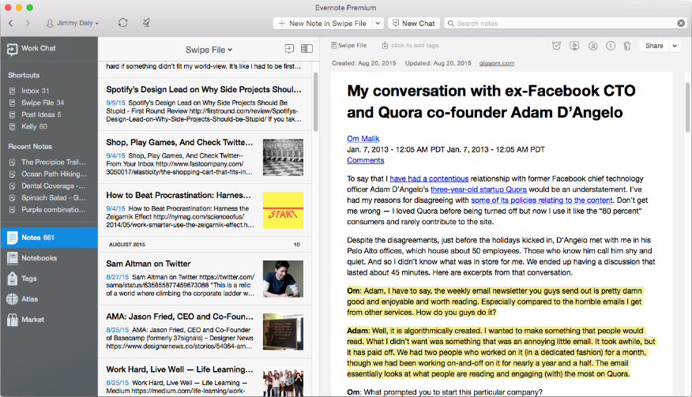<https://zapier.com/blog/best-note-taking-apps/>
* **Evernote (iOS, Android, Mac, Windows, Web)**
* Best for taking notes, scanning documents, and clipping web pages
* [Evernote](http://evernote.com/?utm_source=zapier.com&utm_medium=referral&utm_campaign=zapier) is perhaps the most well-known digital notebook, and for good reason. It’s simple enough to capture quick notes on the go, and still powerful enough to organize your entire digital life.
* Notes in Evernote are much like rich text documents. You can add text, images, audio, and files to notes, then organize them into notebooks. Everything is tied together with powerful search (which can even index handwritten notes and attached documents if you upgrade to [Premium](https://evernote.com/upgrade/?tier=premium&utm_source=zapier.com&utm_medium=referral&utm_campaign=zapier)), so you can find any note no matter where you saved it.
* If you prefer handwritten notes, Evernote makes one of the best document scanning apps as well: [Scannable](https://evernote.com/products/scannable/?utm_source=zapier.com&utm_medium=referral&utm_campaign=zapier). You can scan your handwritten notes, receipts, important documents and more to Evernote just by taking a picture with your phone. Then, you can find any text in the documents, using Evernote's Optical Character Recognition (OCR) to find text from Evernote search. You can search inside images on any plan, then with a paid plan you can also search inside PDF and Office files.
* Evernote's best feature, though, might be its browser extensions. The [Evernote Web Clipper](https://evernote.com/webclipper/?utm_source=zapier.com&utm_medium=referral&utm_campaign=zapier) makes it easy to add just about anything to your notebooks. As you browse the web and discover things you want to remember, just click the browser extension to save highlights or the entire page to your notebook along with any notes you have about that page. It can even save just the text of an article, nicely formatted as an easy way to read your favorite articles later.

1. **GOOGLE KEEP** 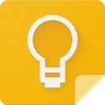

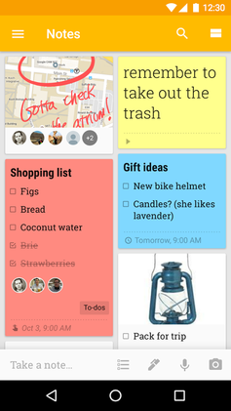

* + <https://www.techlicious.com/tip/best-note-taking-apps-and-devices/>
  + This simple service handles the basics but not much more. You can type notes or make lists online or via an app for iOS or Android, all of which can be organized or searched. It’s not a great option for handwritten notes, as it can’t convert them to text, but it does let you take notes via voice recognition, a handy feature that other apps lack.
  + <http://www.makeuseof.com/tag/google-keep-evernote-alternative/>
  + **PROS**
  + Evernote has some extremely robust features which make it [**great for the workplace**](http://www.makeuseof.com/tag/clever-evernote-features/) and in many ways makes it a [**superior platform to Microsoft’s OneNote**](http://www.makeuseof.com/tag/evernote-better-onenote/). But if you find yourself overwhelmed by Evernote’s many features, **Google Keep is a much simpler alternative**.
  + With the [**Google Keep Chrome extension**](https://chrome.google.com/webstore/detail/google-keep-chrome-extens/lpcaedmchfhocbbapmcbpinfpgnhiddi), you can also save web pages much the same way you would with the [**Evernote Web Clipper**](http://www.makeuseof.com/tag/evernotes-new-web-clipper-is-the-ultimate-content-saving-tool/).
  + Keep really excels in its mobile experience. Adding new notes to Google Keep on your phone is just a swipe away if you enable [**Google Keep’s widgets**](https://support.google.com/keep/answer/2888068) on iOS or Android. Tapping and holding the Google Keep on both iOS and Android pulls up a context menu with the same options.
  + In addition to creating the same notes you can in your browser (text, checklists, photos, and doodles), you can also create a new note using your phone camera or as a [**voice recording**](http://www.makeuseof.com/tag/use-google-keep-voice-notes/) that is immediately transcribed with a native speech-to-text tool, albeit one that only works with brief notes.
  + Another really cool Google Keep feature is the ability to upload a screenshot of text and Keep can convert it to an editable note.
  + Clicking in the search bar takes you to a page where you filter your notes by keyword, color, or even note type (image, link, list, reminder, audio, etc).
  + As you use Google Keep, you’ll find that it also identifies types of notes.
  + Google Keep’s simplicity also lends itself to [**flexibility and creativity**](http://www.makeuseof.com/tag/10-creative-ways-use-google-keep-every-day/). Because it’s so simple, you can mold the service to suit your needs. In its simplest form, Google Keep can be transformed into simple to-do lists. Create a checklist per day or per week to keep a running log of what you’re doing.
  + The use of images or visuals, coupled with the color coding makes Google Keep a perfect choice for anyone who is visually oriented.
  + Everyone has a Google account, but not everyone has an Evernote account. This makes it much easier to [**collaborate on notes**](http://www.makeuseof.com/tag/google-keep-project-management/) with just about anyone. Anyone you share the note with can edit text, lists, images, drawings, and audio recordings.
  + Google Keep is also well integrated with Google Docs. You can export Google Keep notes to Google Docs if you need more robust editing or collaborative features, or if you need more extensive text formatting. And while in Google Docs, go to **Tools** > **Keep** **Notepad** and your Keep notes will appear in a sidebar next to the document, and you can create a direct link between Google Keep notes and Google docs.
  + In addition to working well with Google Docs, Keep also integrates seamlessly with Google Calendar. If you add a reminder to a Google Keep note, that item will also show up in Google Calendar.
  + Google Keep allows you to keep everything in one place. If you take care to keep Google Keep organized whether it’s with labels, or by archiving notes you no longer need, you can use the app for note-taking, brainstorming, audio and photo notes, bookmarking, and even for your to-do or shopping lists.
  + Google Keep’s checklists coupled with the reminders feature, which brings a level of much-needed productivity to any to-do list. You can also check off items at the top of your checklist without actually opening up the app, and checked items are automatically pushed to the bottom of the list.
  + While Evernote has similar features, if you’re drawn in by Google Keep’s simplicity and its visual features, its productivity features will definitely encourage you to stay.
  + **CONS**
  + There are some drawbacks to [**using Google Keep**](http://www.makeuseof.com/tag/bring-google-keep-google-docs-single-click/), particularly if you are migrating from a different note-taking system. Chief among them is the fact that you can’t import your notes. That said, you could look at it as an opportunity to start with a clean slate.
  + Another odd choice on the part of Google is the inability to sort your notes by any particular criteria, but you can drag and drop notes to rearrange them, and you can of course use the search function to drill down and find the note you’re looking for.
  + <https://www.slant.co/topics/697/viewpoints/1/~best-cross-platform-note-taking-app~google-keep>
  + PROS

### PRO  Easy to use

1-step to take a note on android: tap 'take a note'  
Web version: cursor is on the note itself

### PRO  Super fast to use

The focus on a minimal interface makes everything fast to use on both web and mobile. This comes in handy for when a note needs to be jotted down quickly, as there is little to no load times or faffing about trying to get to a space where the note can finally be recorded.

### PRO  Unlimited and seamless sync across all Google connected devices, from mobile to desktop

When a mobile device isn't in use, Google Keep can be accessed as a Chrome app or as a website. Basically, no matter the device being used or the OS on it, there is always a way to access the app. There is also no limitation to how many devices this can be done with, freeing up the user to always have access.

### PRO  Works as a great bookmarking tool as links added can optionally include a preview image

Keep has a great feature that allows you to save sites you visit as a special note type with a link and a preview image.

### PRO  Useful Android home screen widget

The Keep widget lets users quickly see existing notes and add new ones.

### PRO  Automatic saving

Automatically saves new changes so that nothing is lost.

### PRO  Can share and collaboratively edit any item including lists

Keep allows sharing any item with other contacts and editing them together at the same time. This way a team can work together in real time, no matter their location.

### PRO  Notes can be grouped via labels

In addition to the ability to color-code notes, they can be labeled and navigated and grouped that way. This allows for easy organization, to then be found easily at a later date.

### PRO  Supports drawing or writing notes by hand

Newer version of Google Keep now supports drawing on either a blank page, existing notes or in an image attached to the note.

### PRO  Both location- and time-based reminders

You can set reminders that bring certain notes to your attention when you arrive at a specified location or when it’s a specified time or date. Unfortunately you can only do one or the other for each note.

### PRO  Notes can be color-coded

* + Dno obrasca

### PRO  Drag and drop sorting

You can move cards manually, which is great for prioritizing to-dos. Within a card, you can also drag and drop items.

### PRO  Archives finished tasks

Any finished task is archived and can be searched at a later date.

### PRO  Notes can include photo and audio attachments

Notes can include multimedia attachments in addition to text.

### PRO  Really well implemented speech-to-text

Google has a lot of experience with speech-to-text functionality and they did a fantastic job with Keep. This means you can easily record spoken notes that can then be changed to a text based note.

### PRO  Includes character recognition for text in images

Google Keep lets users take pictures of physical notes and makes the contents searchable within the app. This can be a convenient time saver for those that do not want to type out the necessary info, but rather take a quick snapshot of it.

### PRO  Cross platform

This app can be used seamlessly across all platforms including Android, iOS, and desktop computer platforms.

#### CONS

### CON No text formatting

No basic formatting like bold, italics. Makes it harder to do things like meeting notes. Keep is intended as a minimal and quick note taking app, but sadly for those that are looking for something more robust, the features are just not there.

### CON Single-level lists only

There’s no way to set a hierarchy for your lists.

### CON Messy if you have lots of notes

### CON Google can access and mine your data

You have to be okay with Google analyzing and using your data in order to use Keep.

### CON Cannot share groups of notes (e.g., labels)

Google's equivalent of groups are labels, which can't be shared. By comparison, Trello allows you to share boards with others. Trello also supports grouping through teams. Google Keep has no such concept.

### CON Organization is limited to just multiple tags for notes

There are no folders in Keep that you can move notes into. It makes the user interface more cluttered, and navigation gets more difficult.

### CON Not free/libre

This application is proprietary, and thus cannot be modified or freely distributed.

### CON No ability to undo changes

There is no way to revert changes or restore text you may have accidentally deleted (however, you can restore entire notes for up to 7 days after deletion).

### CON Can be taken down some day

As Google is notorious for taking down services, you may end up with just a backup of your notes in XML format and a need to look for a substitute.

### CON No notifications when tasks are added to shared lists

Although the ability to collaborate on lists is advanced, Keep will not let you know when another person adds an item to a list you share.

### CON Can be difficult to discover the features

Google Keep has slowly been introducing new features, but doesn't do a good job of helping you discover them.

### CON Does not integrate with Google Calendar or Tasks

It does not integrate with Google Calendar or other Google Apps with the exception of "Google Now." Keep reminders can appear on Google Calendar, but you can not get reminders and use Tasks at the same time.

### CON Not distributed

Cannot run on own servers as Keep will only run on Google's own servers. This increases the risks which are normally associated with handing over critical applications to a large (US) corporation.

### CON Synchronization bugs

There are some issues with synchronizing data including laggyness and returning old/deleted items.

### CON No way to search within a note

There is no "find" feature for looking up a word or phrase within a note, which can be problematic in larger notes.

### CON Google account required

You're required to have a [Google account](https://myaccount.google.com/) in order to use the app.

### CON No integrated social media sharing

There is no integrated social media sharing if you directly want to post your note to Twitter, Facebook, etc.

### CON No BlackBerry 10 app

No BlackBerry support apart from web.

### CON Does not offer themes

* + There is no option for changing the color theme (such as a dark theme) unless you use a 3rd party extension.

### CON No Windows Mobile app

* + No Windows Mobile app, and it is unlikely to ever be produced.

### CON Too simplistic of an approach

### CON No API

### CON Delay between to-do entries

The keyboard closes and reloads between to-do list entries, so the first letters or words may be missed if you’re trying to quickly create a list.

* + <https://www.apkmirror.com/apk/google-inc/keep/#description>
  + [PRODUCTIVITY](https://www.apkmirror.com/categories/productivity/)
  + Quickly capture what’s on your mind and get a reminder later at the right place or time. Speak a voice memo on the go and have it automatically transcribed. Grab a photo of a poster, receipt or document and easily organize or find it later in search. Google Keep makes it easy to capture a thought or list for yourself, and share it with friends and family.  
      
    Capture what’s on your mind  
    • Add notes, lists and photos to Google Keep. Pressed for time? Record a voice memo and Keep will transcribe it so you can find it later.  
    Share ideas with friends and family  
    • Easily plan that surprise party by sharing your Keep notes with others and collaborating on them in real time.  
    Find what you need, fast  
    • Color and add labels to code notes to quickly organize and get on with your life. If you need to find something you saved, a simple search will turn it up.  
    Always within reach  
    • Keep works on your phone, tablet, computer and Android wearables. Everything you add syncs across all of your devices so your thoughts are always with you.  
    The right note at the right time  
    • Need to remember to pick up some groceries? Set a location-based reminder to pull up your grocery list right when you get to the store.  
    Available everywhere  
    • Try Google Keep on the web at [keep.google.com](http://keep.google.com/) and find it in the Chrome Web Store at [g.co/keepinchrome](http://g.co/keepinchrome).  
      
    Permissions Notice  
    Camera: This is used to attach images to notes in Keep.  
    Contacts: This is used to share notes to contacts.  
    Microphone: This is used to attach audio to notes.  
    Location: This is used to set and fire location-based reminders.  
    Storage: This is used to add attachments from storage to their notes.
  + <https://en.wikipedia.org/wiki/Google_Keep>
  + **Google Keep** is a [note-taking](https://en.wikipedia.org/wiki/Note-taking) service developed by [Google](https://en.wikipedia.org/wiki/Google). Launched on March 20, 2013, Google Keep is available on the [web](https://en.wikipedia.org/wiki/Web_application), and has [mobile apps](https://en.wikipedia.org/wiki/Mobile_app) for the [Android](https://en.wikipedia.org/wiki/Android_(operating_system)) and [iOS](https://en.wikipedia.org/wiki/IOS) mobile operating systems. Keep offers a variety of tools for taking notes, including text, lists, images, and audio. Users can set reminders, which are integrated with [Google Now](https://en.wikipedia.org/wiki/Google_Now). Text from images can be extracted using [optical character recognition](https://en.wikipedia.org/wiki/Optical_character_recognition), and voice recordings can be transcribed. The interface allows for a single-column view or a multi-column view. Notes can be color-coded, and labels can be applied for organization. Later updates have added functionality to pin notes, and to collaborate on notes with other Keep users in real-time.
  + Google Keep has received mixed reviews. A review just after launch in 2013 praised its speed, the quality of voice notes, synchronization, and the widget that could be placed on the Android home screen. Reviews in 2016 have criticized the lack of formatting options, inability to undo changes, and an interface that only offers two view modes where neither was liked for their handling of long notes. However, Keep received praise for features including universal device access, native integration with other Google services, and the option to turn photos into text through optical character recognition.

## Features

Google Keep allows users to make different kinds of notes, including text, lists, images, and audio.[[3]](https://en.wikipedia.org/wiki/Google_Keep#cite_note-Android_Police_features-3) Users can set reminders, which are integrated with [Google Now](https://en.wikipedia.org/wiki/Google_Now), with options for time or location.[[4]](https://en.wikipedia.org/wiki/Google_Keep#cite_note-Greenbot_features-4) Text from images can be extracted using [optical character recognition](https://en.wikipedia.org/wiki/Optical_character_recognition)technology.[[5]](https://en.wikipedia.org/wiki/Google_Keep#cite_note-5)[[6]](https://en.wikipedia.org/wiki/Google_Keep#cite_note-MakeUseOf_features-6) Voice recordings created through Keep are automatically transcribed.[[7]](https://en.wikipedia.org/wiki/Google_Keep#cite_note-Lifehacker_features-7) Keep can convert text notes into checklists.[[8]](https://en.wikipedia.org/wiki/Google_Keep#cite_note-Computerworld_features-8) Users can choose between a single-column view and a multi-column view.[[3]](https://en.wikipedia.org/wiki/Google_Keep#cite_note-Android_Police_features-3) Notes can be color-coded, with options for white, red, orange, yellow, green, teal, blue or grey.[[6]](https://en.wikipedia.org/wiki/Google_Keep#cite_note-MakeUseOf_features-6)[[8]](https://en.wikipedia.org/wiki/Google_Keep#cite_note-Computerworld_features-8) Users can press a "Copy to Google Doc" button that automatically copies all text into a new [Google Docs](https://en.wikipedia.org/wiki/Google_Docs,_Sheets_and_Slides) document.[[4]](https://en.wikipedia.org/wiki/Google_Keep#cite_note-Greenbot_features-4) Users can create notes and lists [by voice](https://en.wikipedia.org/wiki/Google_Voice_Search).[[4]](https://en.wikipedia.org/wiki/Google_Keep#cite_note-Greenbot_features-4)[[8]](https://en.wikipedia.org/wiki/Google_Keep#cite_note-Computerworld_features-8) Notes can be categorized using labels, with a list of labels in the app's navigation bar.[[8]](https://en.wikipedia.org/wiki/Google_Keep#cite_note-Computerworld_features-8)

### Updates

In November 2014, Google introduced a real-time note cooperation feature between different Keep users, as well as a search feature determined by attributes, such as color, sharing status, or the kind of content in the note.[[9]](https://en.wikipedia.org/wiki/Google_Keep#cite_note-9) In October 2016, Google added the ability for users to pin notes.[[10]](https://en.wikipedia.org/wiki/Google_Keep#cite_note-10) In February 2017, Google integrated Google Keep with [Google Docs](https://en.wikipedia.org/wiki/Google_Docs,_Sheets_and_Slides), providing access to notes while using Docs on the web.[[11]](https://en.wikipedia.org/wiki/Google_Keep#cite_note-11)[[12]](https://en.wikipedia.org/wiki/Google_Keep#cite_note-12) [Google Assistant](https://en.wikipedia.org/wiki/Google_Assistant) could previously maintain a [shopping list](https://en.wikipedia.org/wiki/Shopping_list) within Google Keep. This feature was moved to [Google Express](https://en.wikipedia.org/wiki/Google_Express) in April 2017, resulting in a severe loss of functionality.[[13]](https://en.wikipedia.org/wiki/Google_Keep#cite_note-13) In July 2017, Google updated Keep on Android with the ability for users to undo and redo changes.

## Platforms[[edit](https://en.wikipedia.org/w/index.php?title=Google_Keep&action=edit&section=3)]

Google Keep was launched on March 20, 2013 for the [Android operating system](https://en.wikipedia.org/wiki/Android_(operating_system)) and on the [web](https://en.wikipedia.org/wiki/Web_application).[[16]](https://en.wikipedia.org/wiki/Google_Keep#cite_note-16)[[17]](https://en.wikipedia.org/wiki/Google_Keep#cite_note-17) The Android app is compatible with [Android Wear](https://en.wikipedia.org/wiki/Android_Wear).[[18]](https://en.wikipedia.org/wiki/Google_Keep#cite_note-18)[[19]](https://en.wikipedia.org/wiki/Google_Keep#cite_note-19) Users can create new notes using voice input, add and tick off items in lists, and view reminders.[[20]](https://en.wikipedia.org/wiki/Google_Keep#cite_note-20)

An app for the [iOS](https://en.wikipedia.org/wiki/IOS) operating system was released on September 24, 2015.[[21]](https://en.wikipedia.org/wiki/Google_Keep#cite_note-21)

* + 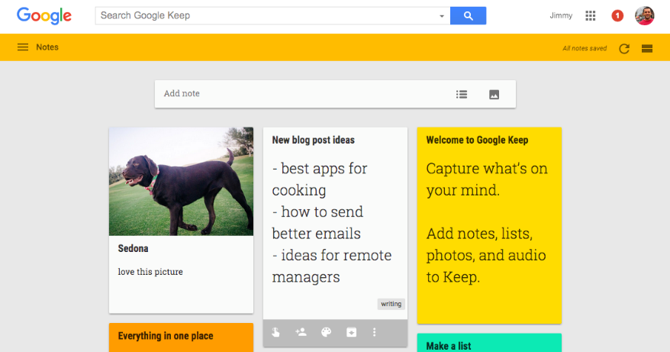<https://zapier.com/blog/best-note-taking-apps/>
  + **Google Keep (iOS, Android, Web)**
  + Best for collecting images, drafting documents, and creating checklists
  + [Google Keep](http://google.com/keep?utm_source=zapier.com&utm_medium=referral&utm_campaign=zapier) might look like a basic sticky-note app, but don't be fooled by its minimalist skin. It's actually a full-featured notes app that's a great place to jot down ideas, create checklists, and much more.
  + The app is stripped down compared to Evernote and OneNote, but that might be just what you need to keep you efficient. You'll write new notes on digital sticky-notes, and then can preview them without having to open each note. If you want to take your notes further, there's a “Copy to Google Doc” feature, which turns any note into an editable Google Doc. And if you write down something you can't afford to forget, Google Keep's location reminders can refresh your memory when you're in a certain area.
  + Google Keep's most useful feature, though, is audio transcription. When you record your thoughts with Keep’s audio recorder in its mobile apps, Google transcribes the text and records the audio. You'll never need to transcribe a conversation again.

1. **MICROSOFT ONE NOTE**
   * <https://www.techlicious.com/tip/best-note-taking-apps-and-devices/>
   * OneNote lets you sort your notes into folders and subfolders, where you can keep notes (typed or handwritten), photos, videos and clippings from the web. Handwriting can be converted to text, whether you’re taking notes with a stylus or snapping a photo of something you’ve scrawled on a napkin. Then everything can be tagged and organized. You can even share and collaborate with others, making it more than a personal note-taking app.
   * All of your notes sync through Microsoft, and apps for Windows, Mac, iOS and Android (plus an offline editing mode) mean you can edit your notes from any device at any time.

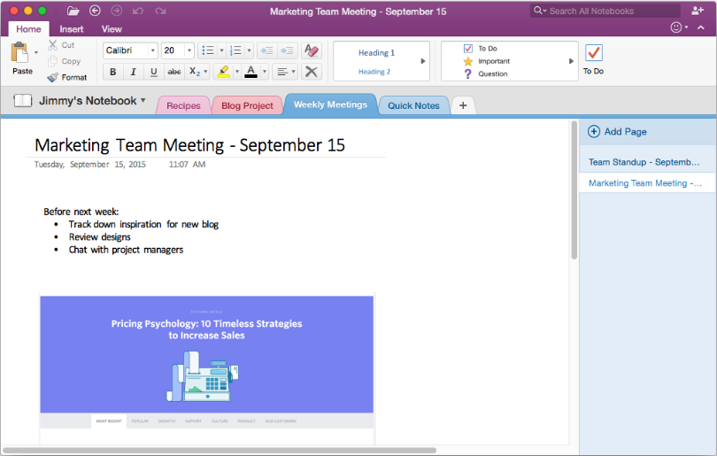

* + <https://zapier.com/blog/best-note-taking-apps/>
  + **Microsoft OneNote (iOS, Android, Mac, Windows, Web)**
  + Best for organizing thoughts, to-do lists, and projects
  + [OneNote](https://onenote.com/?utm_source=zapier&utm_medium=profile&utm_campaign=partnership&utm_source=zapier.com&utm_medium=referral&utm_campaign=zapier) part of the Microsoft Office suite, is a note-taking app that feels a bit more like a paper notebook. Instead of Evernote's more note-centric feel, OneNote is designed around notebooks and note sections. You could easily use Evernote just by relying on search to find what you want—that'd work in OneNote, too, but its notebook and section tabs will make you want to keep things organized.
  + Each note in OneNote feels more like a paper note as well. Click anywhere inside a page, and you can start typing right there, even on the middle of the page. Drag in images and file attachments, then add highlights, notes, to-do lists and more anywhere on your page. You can even include audio, sketches, and videos in your notes.
  + OneNote's flexibility makes it a joy to use. You can keep audio notes next to written notes, mark up images, and add to-dos right alongside your notes to keep yourself on track. And if you're already accustomed to using Office, OneNote's ribbon-style toolbar will make you feel right at home.

1. **APPLE NOTES**
   * <https://www.techlicious.com/tip/best-note-taking-apps-and-devices/>
   * The Notes app already syncs notes to iCloud for easy access across all of your devices, but in iOS 11, you can scan documents with your camera, add your sketches to documents and search through your handwritten notes. Apple Notes doesn’t quite match the features of OneNote or Evernote just yet, but these features are big improvements and could mean this built-in note-taking app has everything you need.
   * 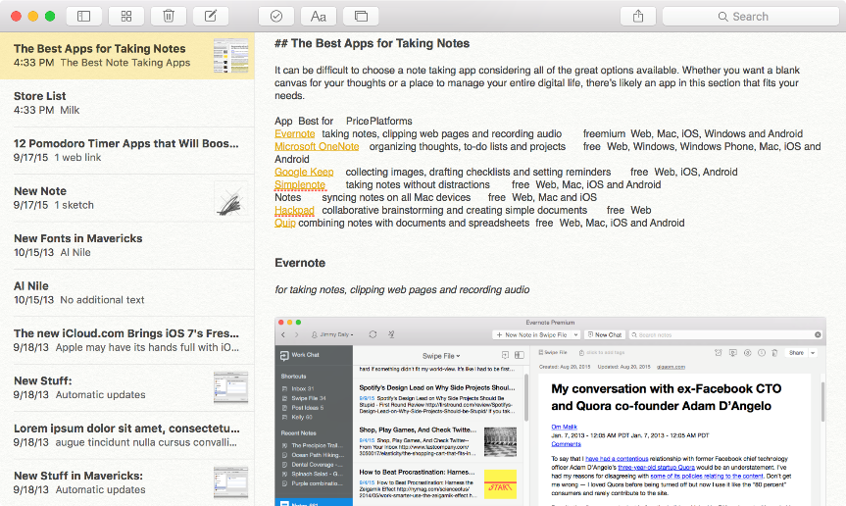<https://zapier.com/blog/best-note-taking-apps/>
   * **Apple Notes (iOS, Mac, Web)**
   * Best for quickly taking notes on Apple devices
   * Often, the best note-taking app is the one you already have. Because Notes comes on every Apple device and works with Siri, it’s the easiest way to write notes on your iPhone, iPad, and Mac.
   * Notes has come a long way since its days as a yellow legal pad. The latest version lets you bookmark sites, draw sketches, write notes with a pen, and create simple to-do lists. Tap the Share button in almost any app on your iPhone or Mac, and you can save favorite articles and more to Notes quickly. And, as always, you can format your notes in rich text and share them over email.
   * Even if you're away from your Apple devices, you can still use Notes via [iCloud.com](http://icloud.com/?utm_source=zapier.com&utm_medium=referral&utm_campaign=zapier). Or, the Notes app can sync your notes to other email services like Gmail and Outlook. It might not be as fancy as the other notebook apps, but Notes removes all friction from jotting things down on the go.